ACE2 Gene Analysis
Variant identification and biological significance
Results:
There are 4 genome-wide statistically significant SNPs associated with the ACE2 gene (GWAS Catalog), namely:
rs4830964, rs190509934, rs60768809, rs35697037
Ensembl VEP analysis showed that rs4830964 is located in the intergenic region, rs35697037 is located in the intronic region, rs60768809 is located in the intron region, and rs190509934 is located in the upstream gene region.
eQTL analysis in the GTx Portal revealed that rs4830964 could affect gene expression in tissues such as lung, esophagus-muscularis, esophagus-GIT, brain-hippocampal, artery-tibial, nerve-tibial, brain-spinal, pancreas, muscle-skeletal, thyroid and spleen. eQTL analysis of rs35697037 also demonstrated similar results.
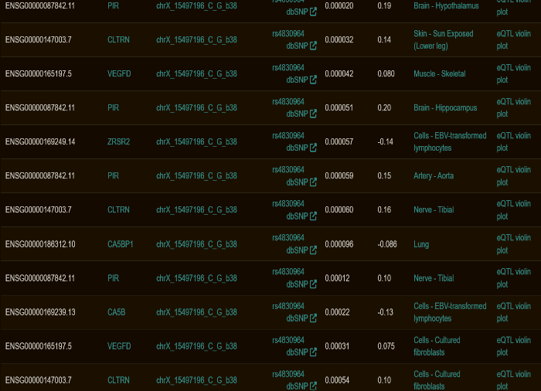
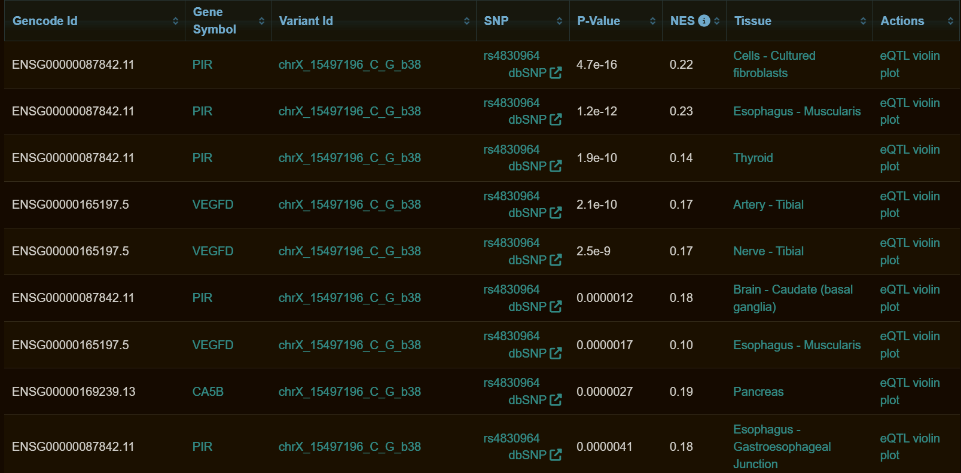
Fig 1.1, 1.2: Results of the eQTL analysis of the variant rs4830964
(Similarly, results were obtained for other variants as well)
However, rs60768809 showed a correlation only with muscle-skeletal tissue gene expression, whereas rs190509934 returned no significant results.
Linkage disequilibrium (LD) analysis in Ensembl indicated that rs4830964 <-> rs35697037 are in very strong LD, with R² = 0.865, and rs35697037 <-> rs4830964 have an R² = 1. There was no other strong evidence of linkage.
miRNASNP database returned no results when entering the variants, because they are not present in the 3’UTR region. The presence of variants in the 3’UTR affects miRNA binding.
Finally, RegulomeDB displayed ranks based on the strength of evidence for the variants' presence in regulatory regions of the ACE2 gene. rs4830964 ranks highest at 1b, indicating strong regulatory evidence, followed by rs35697037 at 1f. The remaining 2 variants have weaker ranks, thus explaining that there is not enough evidence to prove that they are regulatory.
Discussion:
The GTEx-eQTL analysis concluded that the variants rs4830964 and rs35697037 affect gene expression in the lung, esophagus-GIT, esophagus-muscularis, artery-tibial, artery-aorta, brain-spinal cord, brain-hippocampus and spleen. This correctly correlates with existing evidence on COVID-19 infections. The lungs are most affected, followed by the GIT (affecting digestion). Severe COVID infections could cause cardiovascular complications, which are explained by gene expression changes in the artery. Long COVID affects the brain, leading to brain fog and encephalopathy. The eQTL analysis also showed that the variants are associated with differential gene expression in the spleen during infection, corresponding to immune dysfunction.
Meanwhile, though rs60768809 and rs190509934 are genome-wide statistically significant according to GWAS data, there is not enough evidence to support their biological association with COVID-19.

